Ian Borwick - 250950449

Assignment 3 - CS 4442

Contents

Question 1 2

i) 2

ii) 2

Question 2 3

Question 3 5

# Question 1

Show that convolution with a 2D Gaussian kernel is a spatially separable convolution, i.e. there are two 1D kernels if applied to the image row-wise and column-wise in sequence, it is equivalent to convolving that image with the 2D Gaussian kernel.

i) Is Sobel kernel spatially separable?

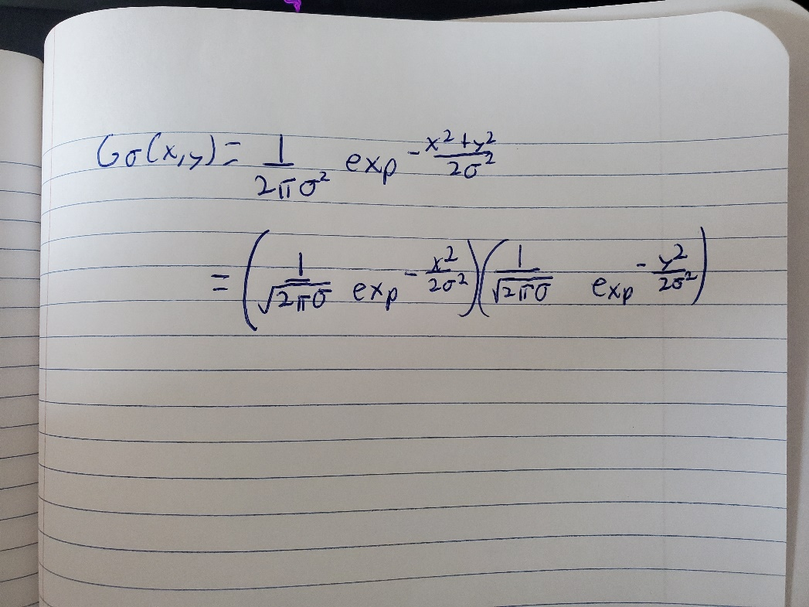

|  |  |  |
| --- | --- | --- |
| -1 | 0 | 1 |
| -2 | 0 | 2 |
| -1 | 0 | 1 |

|  |
| --- |
| 1 |
| 2 |
| 1 |

Yes it is, here is an example Sobel kernel used for edge detection

|  |  |  |
| --- | --- | --- |
| -1 | 0 | 1 |

x

=https://towardsdatascience.com/a-basic-introduction-to-separable-convolutions-b99ec3102728

ii) Why separable convolutions are preferred?

Separability means that a 2D convolution can be reduced to two 1D convolutions, this becomes important when considering time complexity. For example, complexity filtering an nxn image with a mxm kernel you will get a time complexity of O(n2m2) but if the kernel is separable the complexity will be O(n2m).

# Question 2

Please refer to python code iborwick_250950449_asn3_q2.py for source code

Sigma = 3 Low threshold =2 High threshold =20

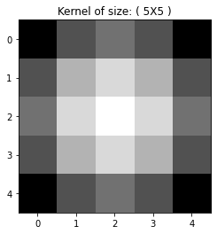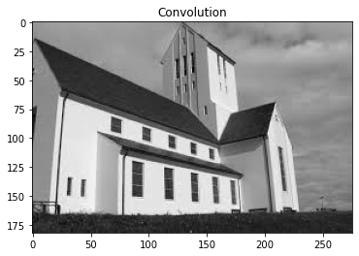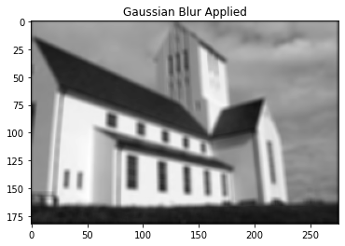

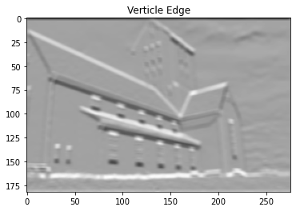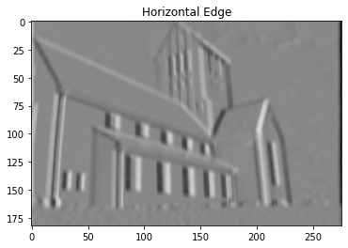

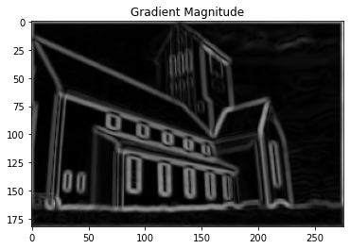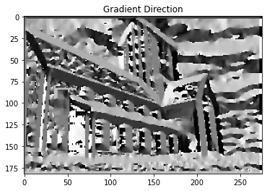

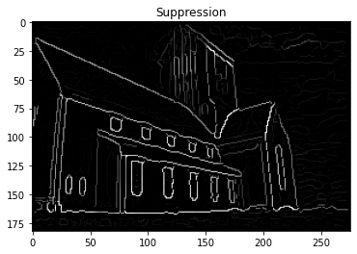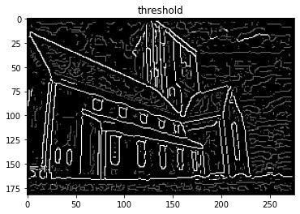

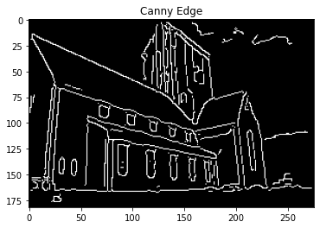

# Question 3

Please refer to python code iborwick_250950449_asn3_q3.py for source code

Window size = 4 k =0.1 threshold = 100000000

